Project Title: Online Retail Segmentation
Project by: Danish Hussain
Date: 19, August 2023.
Github: https://github.com/Danish-Hussain-DSAI/data-analysis-report
Table of Contents
- Introduction
- Project Overview
- Dataset Description
- Data Preprocessing and Setup
- Defining Metadata
- Data Cleaning
- Importing Data into MySQL Workbench
- Beginner Queries
- Distribution of Order Values
- Unique Products Purchased by Each Customer
- Customers with Only One Purchase
- Commonly Purchased Products
- Advanced Queries
- Customer Segmentation by Purchase Frequency
- Average Order Value by Country
- Customer Churn Analysis
- Product Affinity Analysis
- Time-based Analysis
- Conclusion
- Summary of Findings
- Insights Gained
- Future Steps
1. Introduction
Project Overview
This report presents the results of an SQL analysis project conducted on the "Online Retail" dataset. The objective of this project is to gain insights into customer behavior, demographics, and interactions using SQL queries. By exploring the dataset, we aim to provide valuable information to improve decision-making for the online retail business
Dataset Description
The "Online Retail" dataset contains transactional information, including InvoiceNo, StockCode, Description, Quantity, InvoiceDate, UnitPrice, CustomerID, and Country. The dataset offers opportunities to explore customer purchasing patterns, product relationships, and overall business performance.
2. Data Preprocessing and Setup
Defining Metadata
Before diving into the analysis, we defined the metadata for the dataset using MySQL Workbench. This step ensures that each column's data type, constraints, and relationships are correctly established.
Data Cleaning
We performed data cleaning to handle missing values, duplicates, and inconsistencies in the dataset. Clean data is essential for accurate analysis and meaningful insights.
Importing Data into MySQL Workbench
The cleaned dataset was imported into MySQL Workbench, where we executed SQL queries to answer various questions about customer behavior and interactions.
3. Beginner Queries
Distribution of Order Values
We investigated the distribution of order values across all customers. The query revealed the total order value for each customer, enabling us to identify high-value customers.
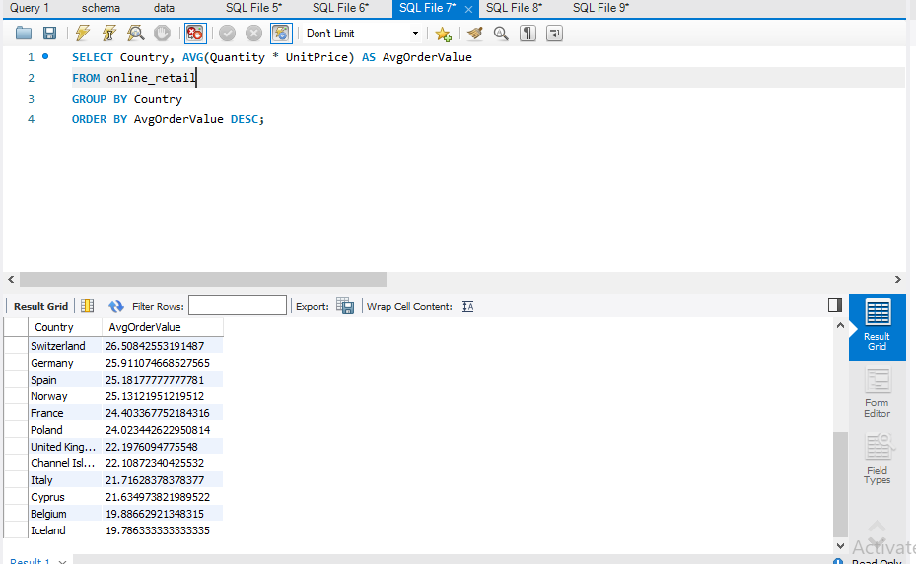
Unique Products Purchased by Each Customer
We determined the count of unique products purchased by each customer. This query helps us understand customer variety in product choices.
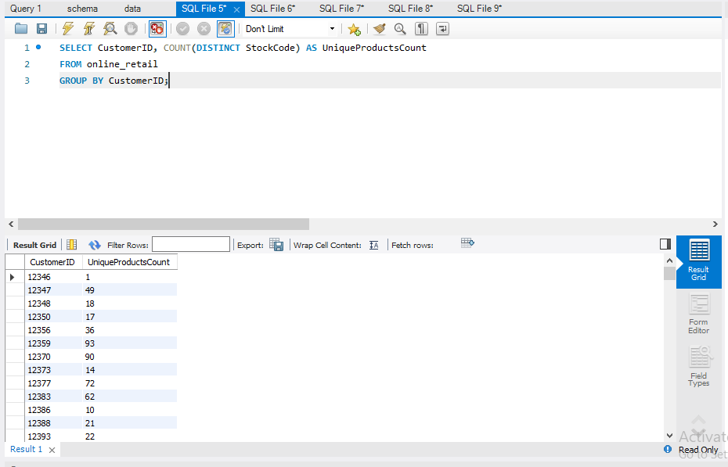
Customers with Only One Purchase
We identified customers who made only a single purchase. This information can guide targeted marketing strategies to encourage repeat purchases.
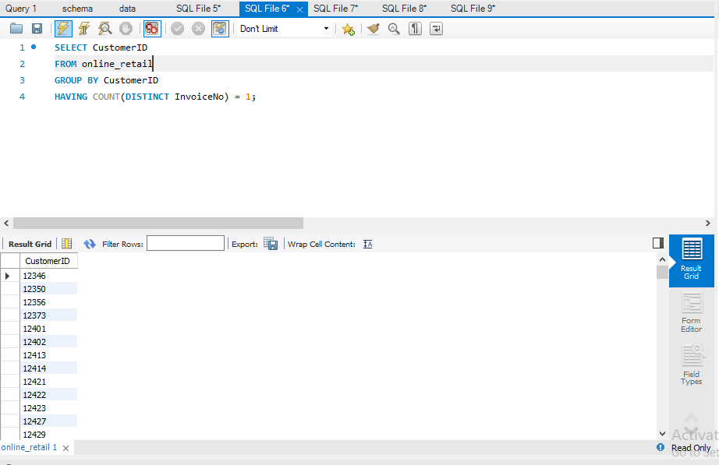
Commonly Purchased Products
By applying more advanced techniques such as market basket analysis, we aimed to identify products frequently purchased together by customers. This analysis provides insights into cross-selling opportunities.
4. Advanced Queries
Customer Segmentation by Purchase Frequency
We grouped customers into segments based on their purchase frequency: high, medium, and low frequency. This segmentation helps identify loyal customers and those needing more attention.
Average Order Value by Country
We calculated the average order value for each country to determine regions with the most valuable customers. This insight aids in optimizing marketing efforts.
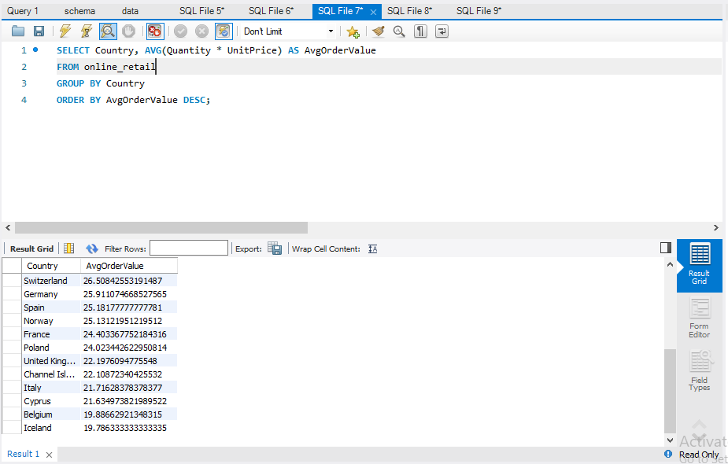
Customer Churn Analysis
By identifying customers who haven't made purchases in the last 6 months, we performed churn analysis to assess customer retention.
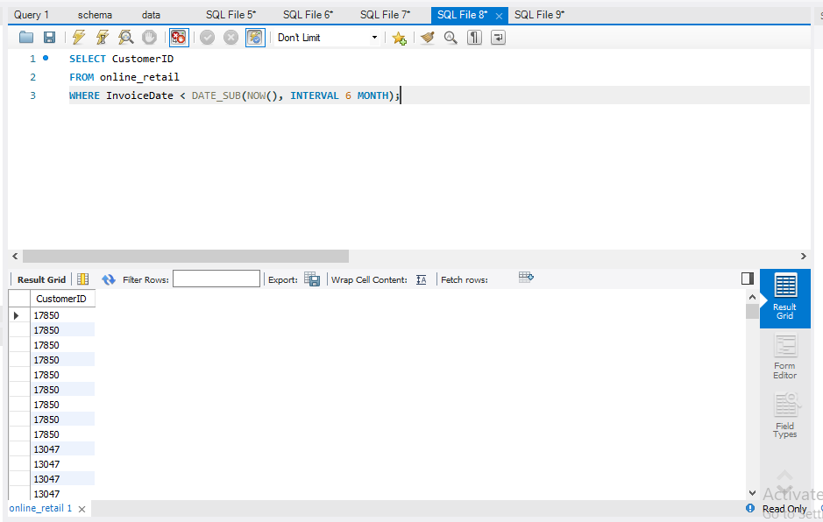
Product Affinity Analysis
Using correlation analysis, we explored which products are often purchased together. This analysis can inform bundling and recommendation strategies.
Time-based Analysis
We explored trends in customer behavior over time, analyzing monthly or quarterly sales patterns. This analysis aids in identifying seasonal trends and adapting strategies accordingly.
5. Conclusion
Summary of Findings
Through SQL queries on the "Online Retail" dataset, we gained valuable insights into customer behavior, purchasing patterns, and interactions. The analysis provided a comprehensive understanding of the business's strengths and areas for improvement.
Insights Gained
The project yielded insights into high-value customers, product preferences, and potential cross-selling opportunities. Additionally, customer segmentation highlighted loyal customers, and churn analysis identified at-risk customers.
Future Steps
To further enhance the analysis, integrating external data sources, conducting advanced statistical analyses, and employing visualization tools can provide deeper insights. Implementing the recommendations based on these insights can contribute to business growth and customer satisfaction.

